SEWER HOSE SYSTEMS (What Works and What Doesn’t)

Jack Mayer, www.jackdanmayer.com
Copyright © 2010 John Mayer. All rights reserved.

You would not think that sewer hoses are a very interesting topic – and perhaps they are not. But it is an important topic if you are an RVer.

As fulltime RVers, we have used lots of different sewer hoses. And I can tell you, there is nothing worse than a cheap hose to spoil your RVing experience. Managing waste is not our favorite activity to start with and dealing with hoses that leak or have to be replaced yearly does not make the experience any better.

Buying a cheap hose is a waste of money – you are going to have to replace it sooner, rather than later. And it will likely be after it leaks on you, or comes apart at the fitting. Hopefully, when you are dumping grey water, and not black!

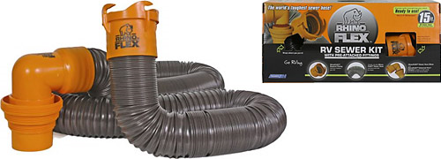
So what hoses work well? We have used the older version of the Rhinoflex sewer hose since it was first available. These hoses were very expensive initially, but once they went into mass production the price became pretty reasonable. WalMart now sells them as the kit shown above for about $30. Camping World sells a similar kit for a little more. So, why do I like the Rhinoflex so much?

- It is made of super-tough material – far more durable than even the “full-timer” hoses you see in places like Camping World.
- It collapses on itself and allows you to adjust its length…and it stays where you put it. You can adjust the length on a 15’ hose down to around 45” without curling or snaking it. You can curve the hose around obstructions and it will stay in place when you pull the valve.
- It comes with good fittings already installed. The bayonet side has four ears instead of two. And the sewer side has a 4-in-1 adapter that fits most sewer pipes without a donut.
They say this fits into a standard 4” sewer bumper or hose holder. But you may have to trim the tabs by the “ears” on the RV side a little. On our Majestic hose carrier you do have to trim it. One other thing to watch out for on this hose is that it “may” work loose from the fittings. Be wise and check the fittings before each use. If you need to extend the hose, you can buy the 10’ length and add your own compatible fittings to bring the total length to 25’. Camco makes a number of accessories that make putting together the “collection” of hoses you need pretty easy – including a 5’ extension with the fittings already on it.
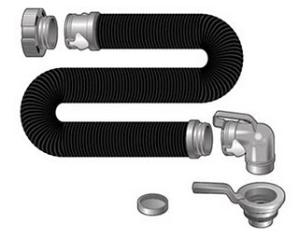
Thetford has recently come out with a new sewer drain system called “Smart Drain.” It is also a complete system, like the Rhinoflex system, and costs in the $60 range. I have to say, the hose part of this system is the best I have seen. They claim it is crushproof – and I believe it. I walked on it without a problem while testing it. It is made a little differently than most hoses since it is not a metal coil wrapped in plastic. Whatever it is made of, it will stand up to some serious abuse. The hose compresses down to around 5’, but it does not stay compressed like the Rhinoflex.

The interesting thing about this system is the fittings. They are completely different than anything I have seen and are based on tab-like “Surelock” connectors to lock in the hoses, as opposed to bayonet fittings that twist on. These connectors lock down after sliding the hose over a matching fitting on the other end. They do lock positively in place, but you have to be careful to line them up. You also need to place a special adapter on the end of your RV sewer pipe (in the picture, the fitting on the top, left). This adapter stays in place and has its own cap to close off the opening when the hose is not connected. The park side of the system is a fairly conventional 4-in-1 adapter. It does have some nice handles on it though.

I used this system for awhile but ended up going back to the Rhinoflex. My main issue was the connection, locked in by the tabs, which started leaking. In my opinion, the hose is super but the connection system needs work.

Dumping Hints

Most of you already know this stuff, but it may be worth repeating for newer RVers:

- When in camp you can choose to leave your grey water valve open. Close it a day before leaving to collect some water to “clean” out the sewer hose after dumping the black tank.
- The black tank is ALWAYS left shut until time to dump. We never dump unless it’s half full and not until we backfill with water first. You want a good gravity-assisted “flush” when you pull that valve. Always dump your black tank first, followed by the grey one.
- If you backfill the black tank with the black tank rinse then make sure you time it with a timer, or you are likely to forget that you are doing it. If you DO forget, one of two things may happen once the tank is full. First, you may overpressurize the seal in your toilet and have water running down the steps inside your RV. Not good. Second, the toilet seal may “hold” and you will have water running out the black tank vent onto your roof, and down the side of your RV. Not good, but better than the first possibility. (Ask me how I know this ☺)
- Use a clear elbow so you can see the condition of the “stuff” in your black tank. You will also know when it is empty.
- You do not need chemicals in your tanks.
There are other hose systems out there. I have tried many of them, and settled on the Rhinoflex. This is not the only “good” solution available, but it is one of the better ones. If you do not want to mess with the large hoses at all, check into the Sani-Con system by Thetford, which is a macerator-based sewer drain system. If I was moving to another system, this would likely be my choice.

Happy dumping, and . . . you might want to watch Robin Williams in the movie RV for further tips on what “not to do.”

